|  |  |
| --- | --- |
| ***MEETING MINUTES*** |  |

**SCRIBE:** Gaby Tulchinskaya

**PROJECT:** GreenSheets Re-Design

**MEETING NAME:** GreenSheets Re-Design

**ATTENDEES:** OGA:Crystal Wolfrey, Eugenia Chester, Stacey Kocher

CBIIT: Jennifer Kwok, Gerald Momplaisir, Yakov Polonsky, Larry Brem, Gaby Tulchinskaya, Subashini Varadarajan.

**MEETING DATE/LOCATION:** 04/06/2017; 9609 Medical Center Dr., Meeting Room # 2W032/034

**Purpose of the meeting is to discuss:**

* UI mockups (see screenshots below the table) for:
  + Greensheet questionnaire screen
  + Specialist search and hit list screen

**Discussion and decisions**:

|  |  |
| --- | --- |
| Topic | Decisions |
| Greensheet questionnaire screen | **Header:**   * During UAT OGA will decide if page header should be expanded or collapsed by default * Specialist Code and Program Director code should be deleted done * Back-up specialist still should be displayed in the header it is there * OGA will have an internal discussion and let CBIIT know what other information (if any) should be displayed in the header * “Last Changed By” should display a name (hypelinked); This label and information should appear in the header only when gs has been saved done * ‘Submitter’ and ‘Submitted Date’ should appear only when gs is in Submitted and/or Frozen status. Already done this way * If gs is unlocked (status is Unsubmitted), ‘Submitter’ and ‘Submitted Date’ should disappear. NOTE: Submitted date should NOT be displayed for this row in the hit list as well (existing functionality) for unsubmitted gs.   **Links to IMS/FCOI/FACTS**:  CBIIT needs to check if it’s possible to have appl_id within the link   * If it’s possible, then keep displaying the links on Greensheet questionnaire screen * If it’s NOT possible, then OGA will add the links to the question in Form Builder and links should be deleted from the Greensheet questionnaire screen   **Print button**   * OGA has no preference on screen placement * Can be renamed to “Create PDF”, if CBIIT decides so * Crystal uses this functionality (possibly others) to create PDFs for Frozen greensheets and she always using the same settings (“Main and all Answered subquestions” and “Questions and Comments Together”). Therefore, there is no need for other PDF options. When a user clicks “Print’ button, a PDF should be generated with these settings. * Generated PDF should have everything that is displayed on the screen. If some changes on the screen were not saved, they still should be part of the PDF.   **Cancel Changes functionality**   * Remove, not needed - done   **Clear All Answers functionality**   * Should be renamed with ‘Reset Greensheet’ done * When user clicks ‘Reset Greensheet’ button, the system should:   + Provide a warning message “Are you sure you want to reset the greensheet? All answers, comments and attachments will be deleted and the Greensheet status will be reset to “NOT STARTED”. Click OK to confirm the reset.”   + Options are “Cancel” (default) and “OK”.   + If user clicks OK, the system will delete answers/comments/attachments, change the status to NOT STARTED and save the changes. – but does it record last changed by? – because technically it was changed?   **Answer options in the dropdown**   * OGA requested to substitute ‘Select an Option” with blank row. CBIIT responded that this option is controlled in the Form Builder by OGA users.   **Discussion related to expand/collapse questions options**   * New requirement: all saved answered questions should be always expanded (no ability to collapse answered question should be provided). * CBIIT proposed that when a user initially comes to the screen (gs is in NOT STARTED status), there are no icons that indicate existence of sub-questions. Top level question should be answered before expand/collapse icons are displayed for a question with sub-question(s). Crystal mentioned that a sub-question indicator is useful.   The decision has been made to keep proposed approach until the future demo to a bigger OGA group. During the demo, OGA will re-evaluate this functionality. The idea to provide ability to preview ALL sub-questions without entering an answer to a top-level question has been discussed. That’s a not a good iidea and would be a confusing UI practice – no other UI that I know of works that way  **Close the gs screen**  User can close the gs screen either by clicking on the back button or “X” in the corner of the browser window or by clicking on Back to Search link. In all cases, a warning should be displayed “You are leaving the current form. Any unsaved changes will be lost. Click OK to continue.”  This is existing functionality that should be kept with re-design. Added to back button |
| Additional changes related to a scenario when a new template has been promoted from Form Builder | OGA will provide revised text and formatting (if necessary) for a warning at the top of the screen. (Current text on the mockup: The Greensheet template has been updated and the questions might have changed. The system automatically matched the answers and attachments to the questions that did not change (if any). Please check for correctness and enter answers to the questions. To copy an attachment (if exists) that was saved before the template was updated, click on the attachment icon for the selected question and chose “Copy” from the Previously Saved Attachment(s) List.” |
| Specialist search | * FY – default to current FY done * Break up grant number into components (Type, Mech, Serial Number, etc) Use 193829 for example * Keep all proposed search criteria |
| Specialist hit list | * All columns in the way information is displayed has been approved * If user navigates from the hit list to a greensheet and comes back by clicking Back to Search link, all search criteria and search results hit list should be retained. |

**Mockups**

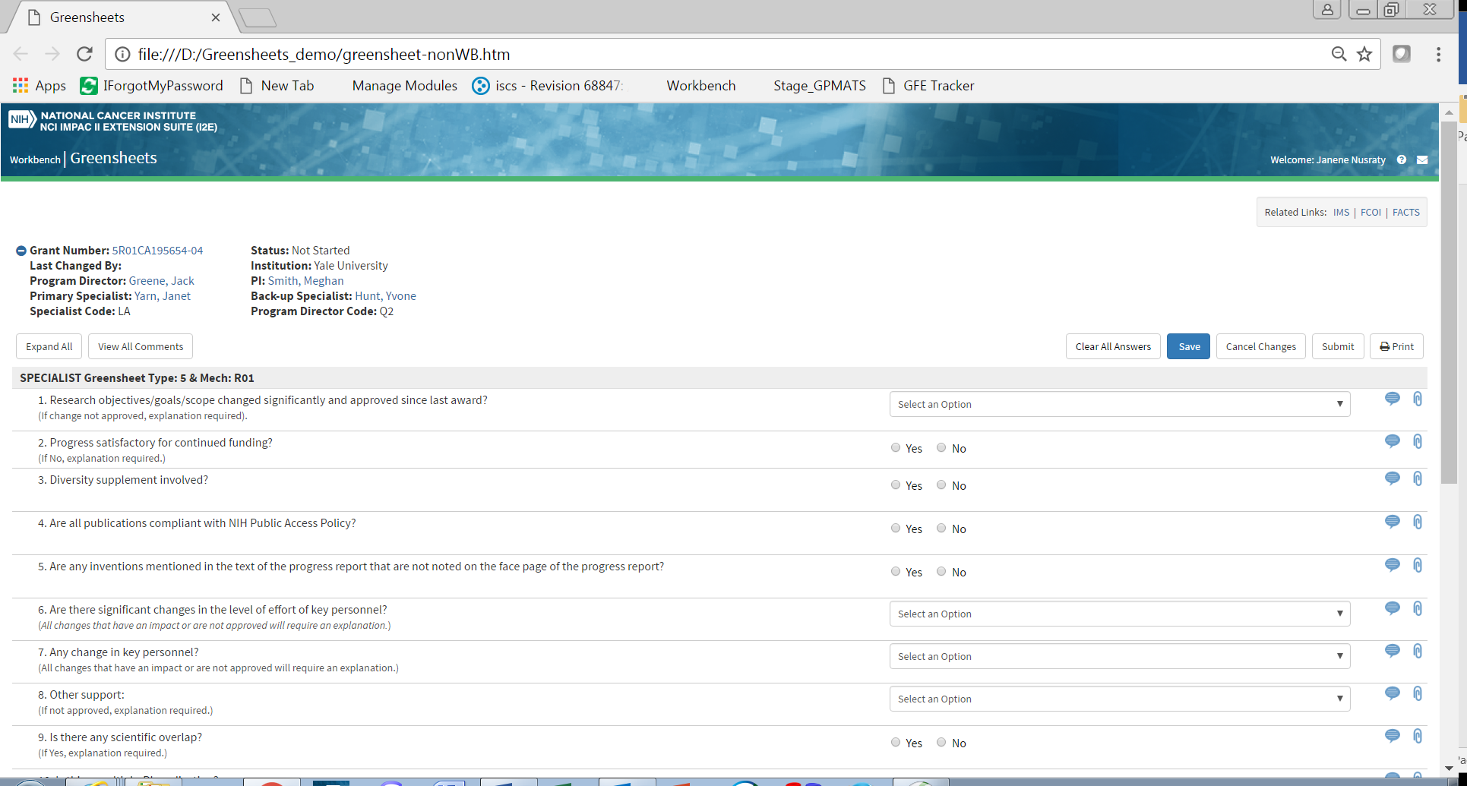

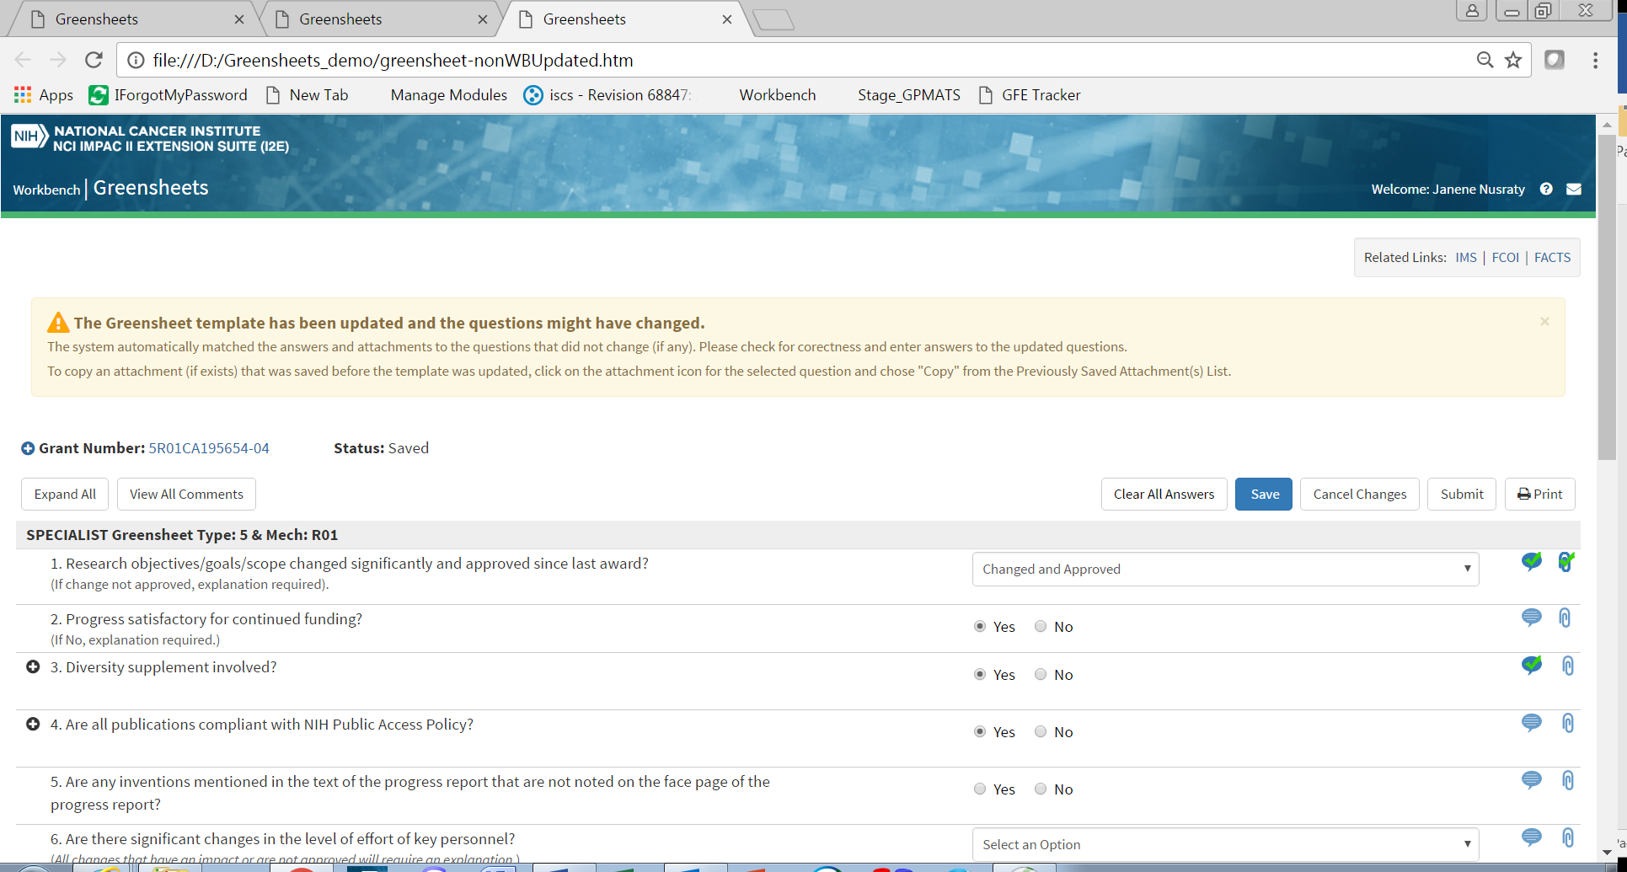

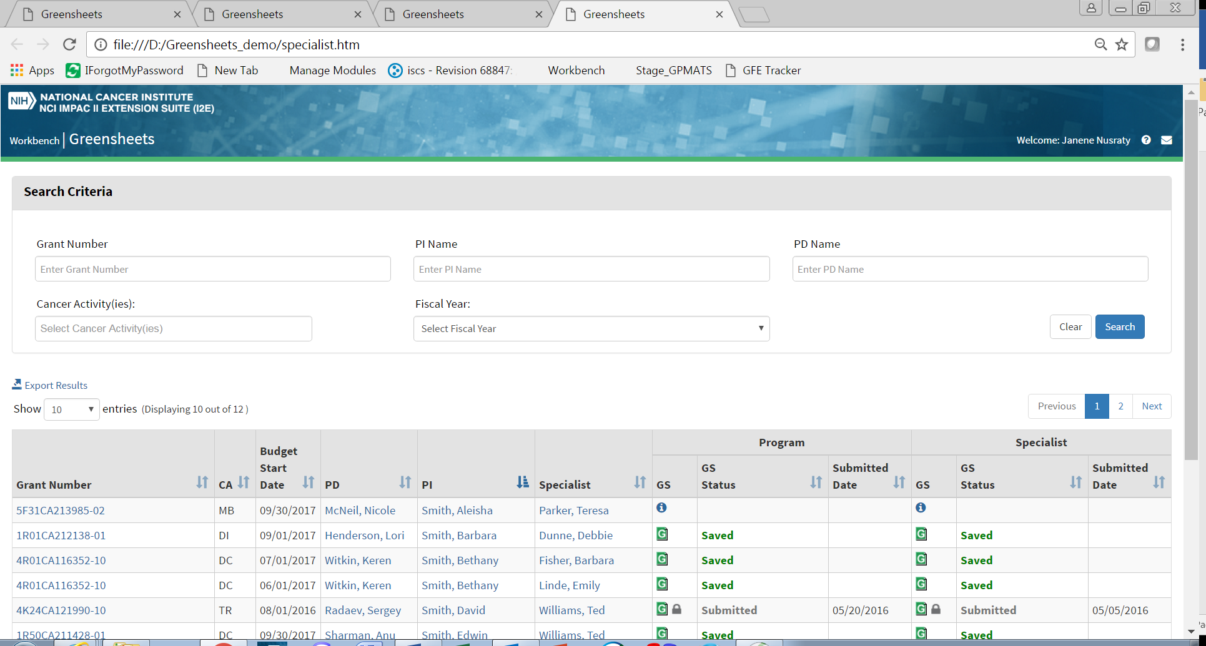

**Action items**:

| Item | Action | Related to | Status | Responsible party |
| --- | --- | --- | --- | --- |
|  |  |  |  |  |
|  | Provide the text for a warning message OGA will provide a text and formatting for a warning at the top of the screen. (Text on the mockup: The Greensheet template has been updated and the questions might have changed. The system automatically matched the answers and attachments to the questions that did not change (if any). Please check for correctness and enter answers to the questions. To copy an attachment (if exists) that was saved before the template was updated, click on the attachment icon for the selected question and chose “Copy” from the Previously Saved Attachment(s) List.” | When greensheet is in status “Saved” or “Unsubmitted” and a new template is promoted from Form Builder, GreenSheets system will display a warning message that the template has changed and instructions to a user. | Open | OGA |
|  | OGA will have an internal discussion and let CBIIT know what other information (if any) should be displayed in the header | The header of questionnaire | Open | OGA |
|  | CBIIT needs to check if it’s possible to have appl_id within the link to IMS/FCOI/FACTS | Links IMS/FCOI/FACTS | Open | CBIIT |